3.74: In the frame of the hero, the range of the object must be the initial separation plus the amount the enemy has pulled away in that time. Symbolically, 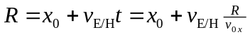, where 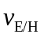 is the velocity of the enemy relative to the hero, t is the time of flight, 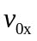 is the (constant) x-component of the grenade’s velocity, as measured by the hero, and R is the range of the grenade, also as measured by the hero. Using Eq. (3-29) for R, with 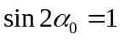 and 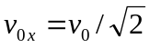,
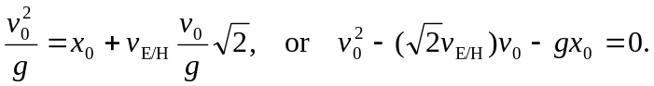
This quadratic is solved for
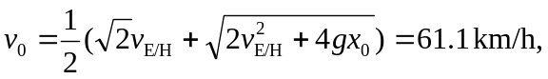
where the units for g and  have been properly converted. Relative to the earth, the x-component of velocity is , the y-component, the same in both frames, is 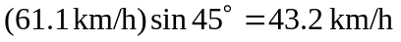, and the magnitude of the velocity is then 140 km/h.

